Step 1: Created AWS Account

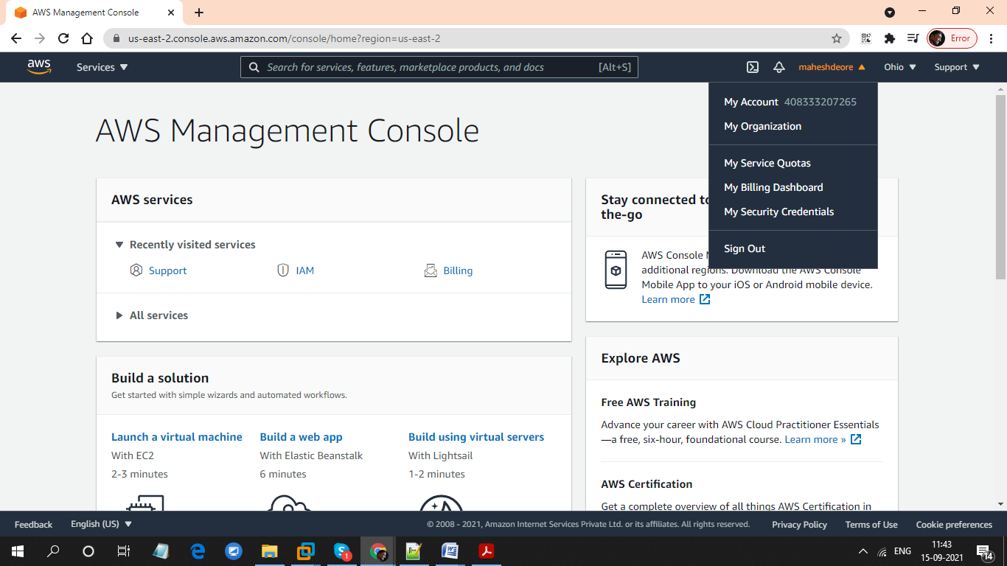

Step 2: Adding User

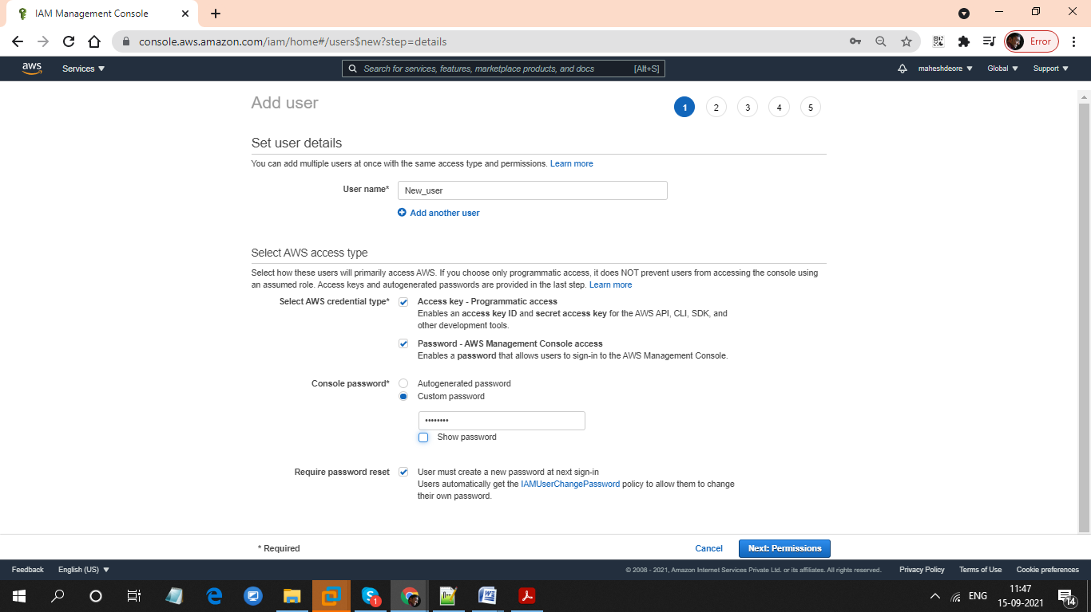

Step 3: Adding Permissions

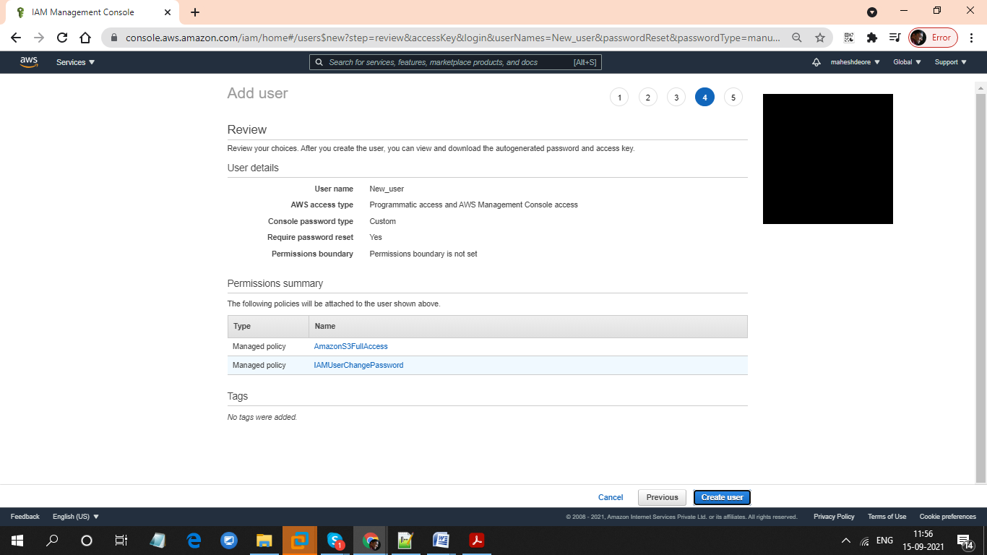

Step 4: Added IAM used

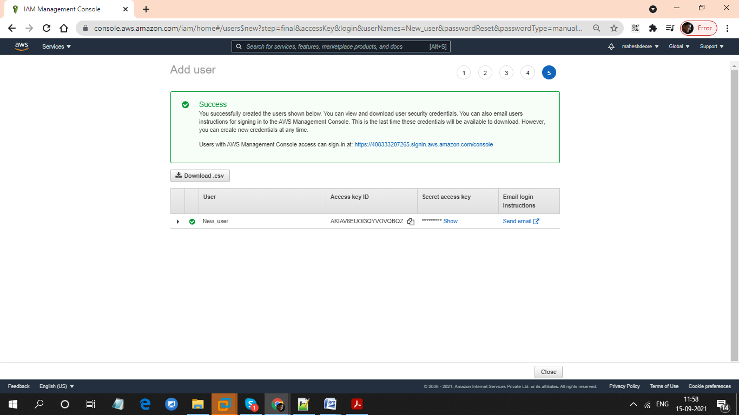

Step 5: User with Permissions

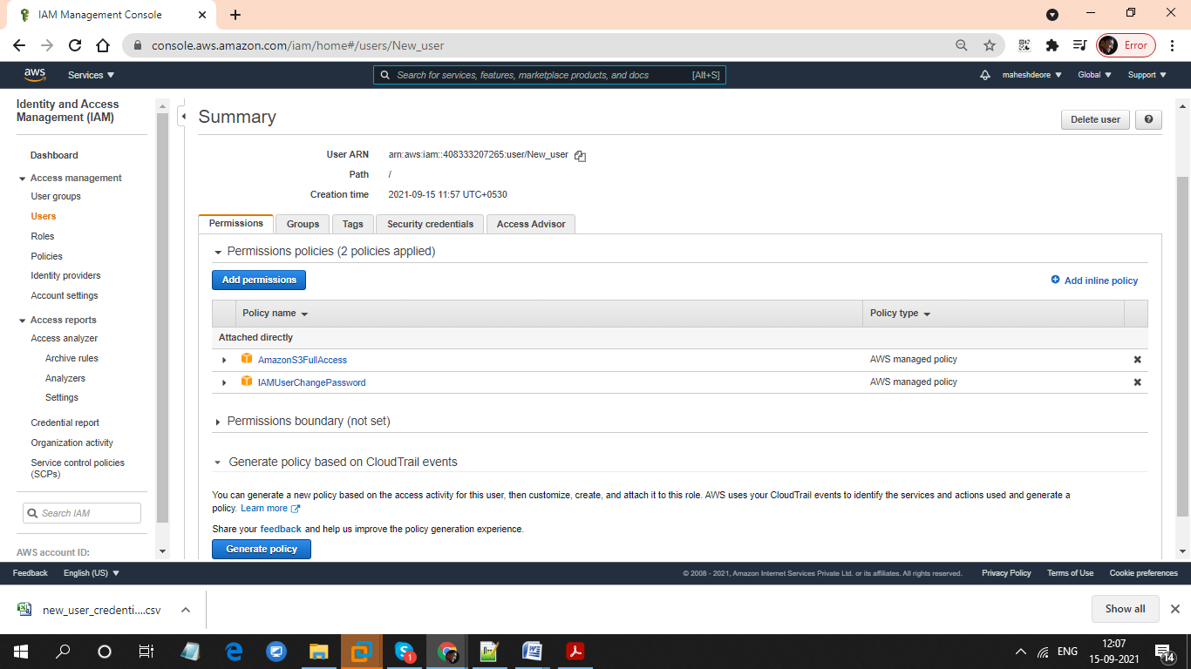

Step 6: Logged in as a ‘New_user’ (Login Interface for New_user )

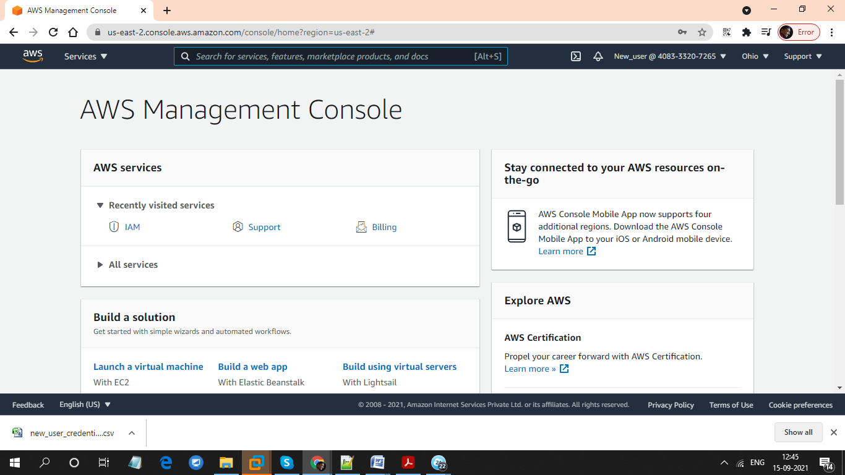

Step 7: Create Bucket Access

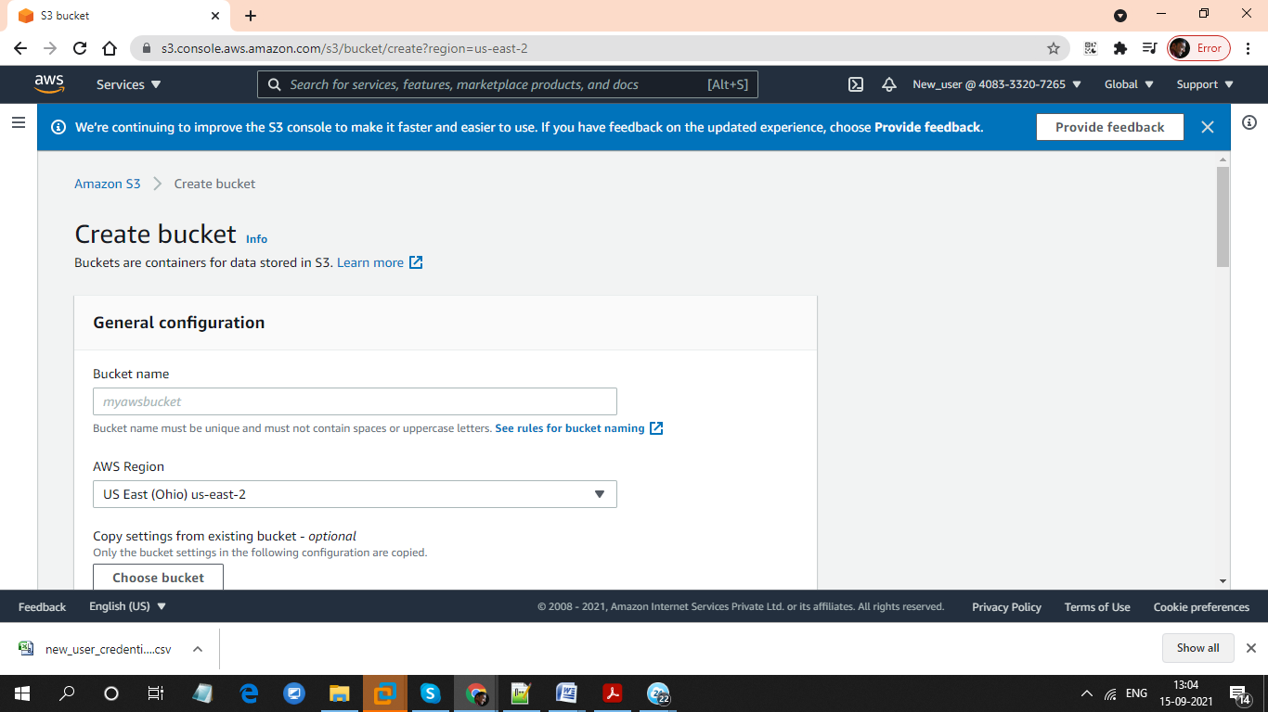

Step 8: Verify EC2 Access

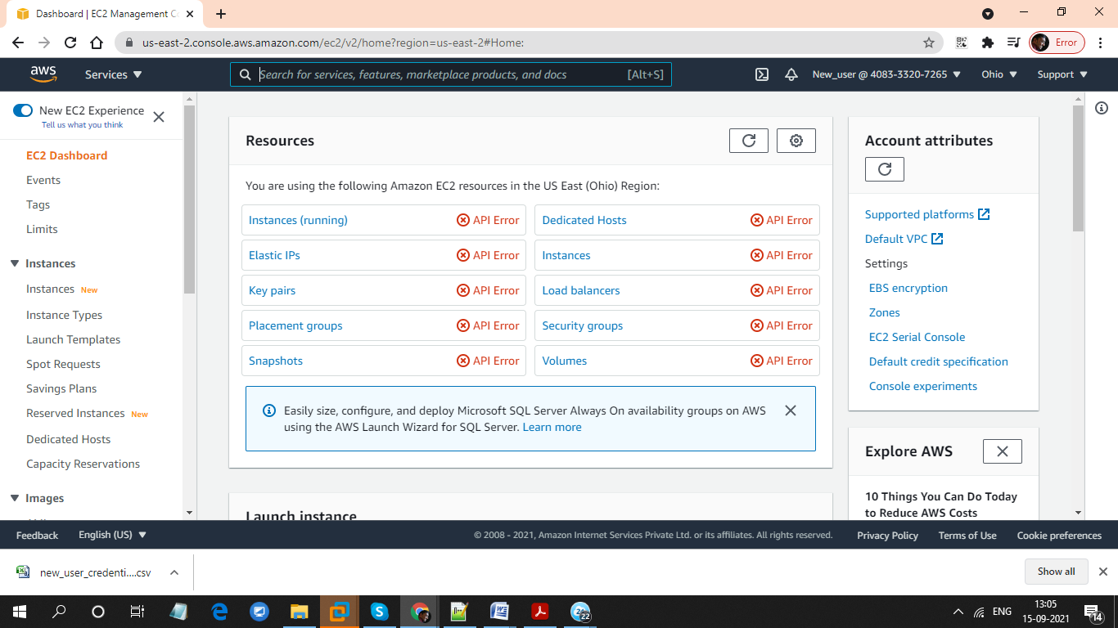

Step 9: Do not have permission to IAM User

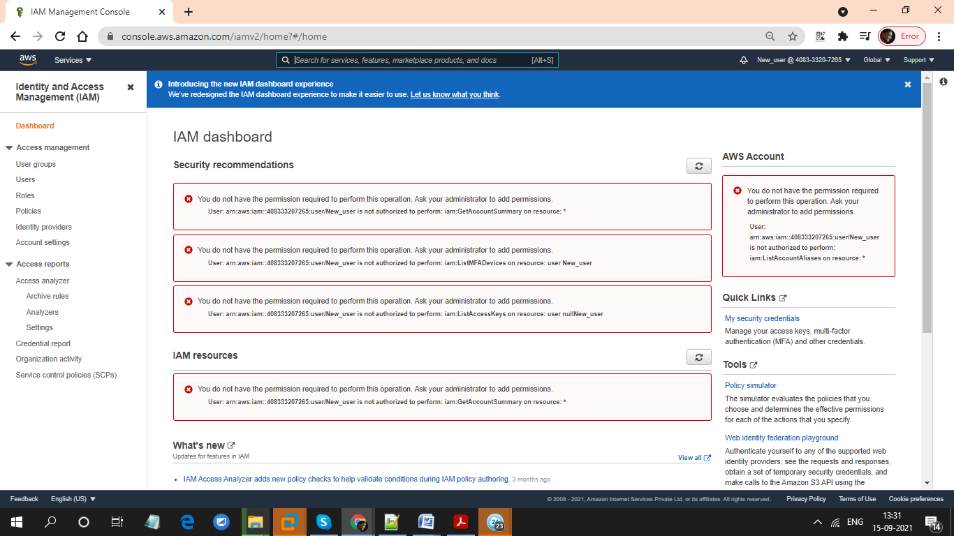

Step 10: Created Bucket

